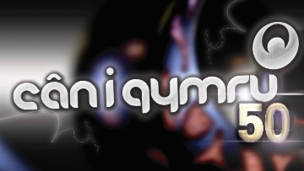
CÂN I GYMRU 50 APPLICATION FORM
NAME:

ADDRESS:

HOME PHONE NUMBER:

MOBILE PHONE NUMBER:

E-MAIL:

DATE OF BIRTH:

SONG NAME:

LYRICS:

COMPOSER:

A SUGGESTION OF WHO YOU WOULD LIKE TO SING THE SONG:

Please read the competition rules before going any further.

For a copy of the rules please click here

or phone 02920 838140 for a copy through the post (24hr answering machine)

Tick here to confirm that you have read, understood and agree with the terms of the competition.

Tick here to confirm that you have read, understood and agree with the terms of the Privacy Notice.

CD / MP3

Copy of the lyrics on paper or Word Document
Send in your application form and song before 5pm on Friday the 4th of January 2019.

Post:  Cystadleuaeth Can i Gymru 2019,  Avanti Media,  36 Heol Caerdydd,  Llandaf. Caerdydd.  CF5 2DR | E-mail:  canigymru@avantimedia.tv

